Jennifer Stegina

20 September 2019

CIS 250

**Unit 4 Graded Exercise 4**

The following questions come from the “Check your understanding” examples of Chapter 14 in your textbook.

After you are finished, please submit a Microsoft Word file that contains screenshots of the SQL queries, the output, and a comment in the query file with your name. Your document should be named **U4_GradedExercise4_Lastname.docx**.

(14-8) Question 1:

The following *select* statement shows the number of orders for each food on the menu. Modify the SQL so the result table shows that there are no orders for broccoli.

*select a.description as food_item,*

*sum(b.quantity) as number_of_orders*

*from l_foods a,*

*l_lunch_items b*

*where a.supplier_id = b.supplier_id*

*and a.product_code = b.product_code*

*group by a.description*

*order by a.description;*

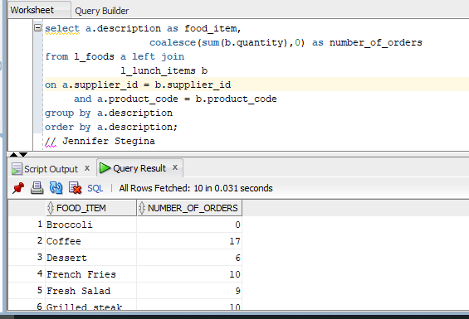

(14-12) Question 2:

The table *sec1412_departments* is similar to the *l_departments*table, except that a few rows have been added, deleted, or changed. Find all the differences between the two tables.

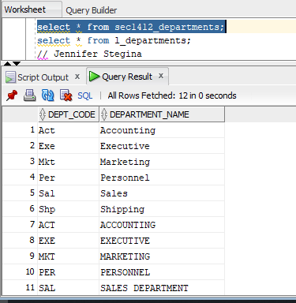

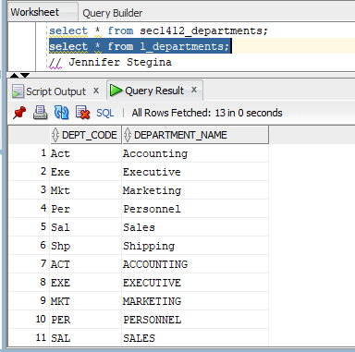

To start, sec1412_departments has 12 rows compared to the 13 rows of l_departments. The table sec1412_departments has both a mixed case and uppercase row for accounting, executive, marketing, personnel and sales. The table sec1412_also has an uppercase row for shipping and information technology.

L_departments has 13 total rows with uppercase and mixed case rows for accounting, executive, marketing, personnel, sales, and shipping. L_departments also has an uppercase row for information technology.